GRADE | 10 | SUBJECT |  | CAT |  | WEEK |  | W4  L3 |  | TOPIC | Solution Development: Word Processing –Document and Page Layout (Margins & Headers and Footers)
LESSON SUMMARY FOR:
DATE STARTED |  |  |  |  |  |  | DATE COMPLETED
LESSON OBJECTIVES |  |  | At the end of this lesson the learner must be able to:  - Know how to customise Margins  - Insert Headers and Footers in a word document  - Edit Headers and Footers
TEACHER ACTIVITIES |  |  |  |  |  |  |  |  | LEARNER ACTIVITIES |  |  |  | TIMING | RESOURCES NEEDED
1. Methodology  - Worksheets (Data Folder )  - Power point presentation  - Text book  - Class discussion and Hands on practical work by learners  2. Introduction  Note to teacher : This lesson plan covers two topics : Margins and Headers & Footers  Introduce learners to:  Margins:  Page margins : Page margins control the amount of blank space around the edges of the page in your Microsoft Word document.  Headers and Footers:  Page margins are usually left blank, but they can actually contain items such as headers, footers and page numbers  3. Main Body (Lesson presentation)  How to see your page margins:  Click View > Show > Ruler, and the ruler will appear along the top and left edges of your workspace. The ruler shows where the margins are set. Alternatively, if you click View > Show > Gridlines, the grid will how you where your content ends and your margins start.  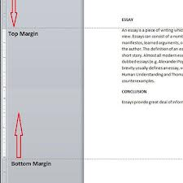  Note : Gridlines, the grid will show you where your content ends and your margins start.  Setting Margins  Click Page Layout >Margins > Custom Margins  Or you can choose those that are pre-set  Custom Margins allows you to define your own margin widths.  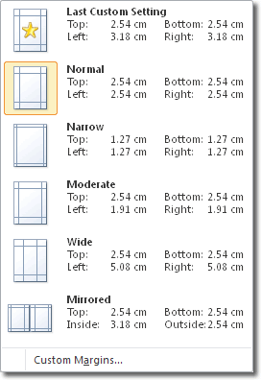  When you select Custom Margins, the Page Setup window opens  At the top of the window you can see the settings for the top, left, bottom and right margins  Note : Settings should be in centimetres (cm). This will be the case if you have centimetres as the default unit in Word.  Headers and Footers  Headers and footers are areas in the top, bottom, and side margins of each page in a document.  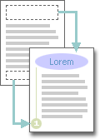  Text can be changed and graphics can be added in headers and footers. For example, you can add page numbers, the time and date, a company logo, the document title or file name, or the author's name  - Insert a header or footer  - On the Insert tab, in the Header & Footer group, click Header  or Footer  - Click the header or footer design that you want.  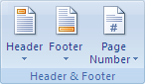  Customizing your header or footer  - On the Insert tab, in the Header & Footer group,  - Click Header or Footer.  - Click Edit Header or Edit Footer.  - Type text or insert graphics and other content by using the  options in the Insert group on the Design tab, under  the Header /Footer  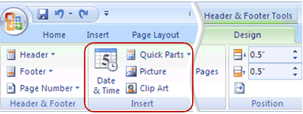  - Sources :  - http://www.word-2010.com/setting-margins-in-word/  http://office.microsoft.com/en-za/word-help  4. Conclusion  Margins and Headers & Footers add layout efficiency and ease of access for references to the document. |  |  |  |  |  |  |  |  | Folder DataFiles_Solutions  for learners to practice  Computers  Part of your Life  p. 171 Act 1  p. 225 Act 8  Via Afrika  p.  Focus  p.152 Act 5 |  |  |  | Introduction and definition 10 minutes  The rest of the time allocated on explanation of the lesson | PowerPoint presentation  Data projector  Prescribed Textbooks  Computers  Part of your Life  p.169-170 & 224-225  Via Afrika  p.  Focus  p. 153  p..151-152  .

Name of Teacher: HOD:
Sign: Sign:
Date: Date:

